Important Changes to Your Testing Regime
Dear Colleague,

Firstly, we want to thank you for all your efforts and support of the testing programme from the outset. We are grateful to you for working with us to continue to protect the lives of colleagues, and the vulnerable people you care for.

Secondly, as the country moves from Plan B with the removal of restrictions, this newsletter sets out changes to the testing guidance for home care staff that will be introduced following advice given by the Scientific Advisory Group for Emergencies (SAGE) to ensure you and the people you care for remain protected from Covid-19, whilst simplifying the testing regime. This newsletter provides more detail about these changes and next steps for you. Full guidance will be published next week.
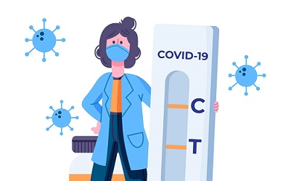

Staff Testing Updates
- An enhanced testing regime of pre-shift LFDs for all staff on each of the days they are working, and the removal of the weekly asymptomatic PCR testing for staff.
- There will be no change in PCR testing for staff symptomatic testing, or any other PCR testing for staff eg when they’re a contact.
Based on SAGE Social Care Working Group advice, following the pre-shift testing regime provides better protection than the current regular testing regime of weekly PCR testing. The introduction of pre-shift rapid lateral flow tests should help identify and isolate positive cases more quickly rather than waiting for PCR results to return from the lab. This will be testing maximum once per day and for live in carers, it is advised that tests should be taken as close to the beginning of the day as possible and 24 hours apart.

From Friday 28 January, you will be able to place an order for LFDs for your staff. When you place an order, we will send you enough LFDs for all your staff to undertake pre-shift LFDs for everyday they are working. These can be used at home by staff members. To do this, you should navigate to the usual organisational testing portal [link] and use the same Unique Organisation Number that you currently use to order PCRs, and you will see the option to place an order for staff LFDs. Please input the number of staff you have and then confirm your contact details to place an order. Once you have ordered tests, you'll receive a confirmatory email from: organisation.coronavirus.testing@notifications.service.gov.uk

Tests can take up to 7-10 working days to arrive following your order. Once they have arrived, we ask that a month’s worth of tests are distributed to your staff to enable them to conduct tests at home. We are asking all organisations to implement these testing changes by the 16th February.

Ordering LFDs is independent to the orders placed for PCR tests; so if you have recently placed an order for PCR tests, you will still be able to order LFDs from Friday 28th January.

You can find more details of all the changes detailed above in this letter from
Claire Armstrong - Director of Adult Social Care Delivery and Covid-19 Response, Department of Health and Social Care. In addition, a full guidance document will be published next week on the testing page on gov.uk.

Thank you,
NHS Test and Trace

